# **Changing Workflow to Support Screening for breast cancer**

In our clinics, the rate of screening for breast cancer is lower than state averages (see graph). Recently, a 55-year-old woman was diagnosed with breast cancer who had 10 prior primary care appointments without documented discussion of screening for breast cancer.

**Proposal**

* Use “magic template” to host order set for screening (Appendix 1)
* Empower non-provider staff to order mammography during rooming (Appendix 2)
* Institute universal rooming templates

**Rationale**

The clinical recommendations are consistent with the United States Preventive Services Task Force (USPSTF, 2009)

**Cost of implementing**

* We project loss of revenue from staff time, thus it is essential that non-providers contribute the most time. We cannot quantify indirect costs, such as damage to reputation from awareness of low compliance with a commonly accepted component of primary care.
* Details of estimates are in the Appendix

**Alternative proposals**

* xyz could be implemented, but…

**Additional considerations** (optional section)

* This proposal also creates structure to add other preventive care to a standardized rooming process.

**References:**

1. USPSTF. Breast Cancer Screening. 2016. Available at <https://www.uspreventiveservicestaskforce.org/Page/Document/UpdateSummaryFinal/breast-cancer-screening1>

## Appendix 1 (detail of findings)

Add the four questions in red to the exissting smoking cessation folder ***(this appendix is from another project)***

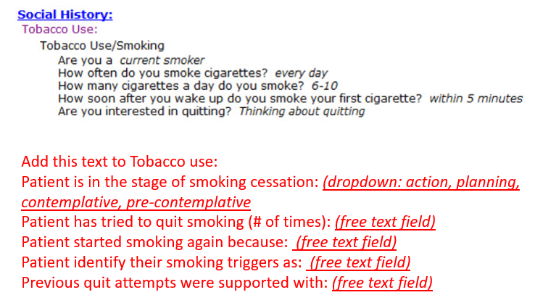

### Appendix 2 (screen captures of proposal; workflows)

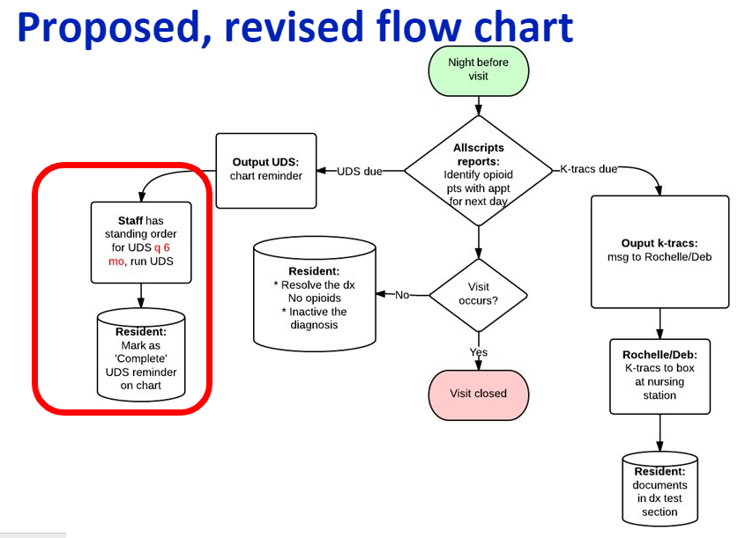

Proposed EHR templates:



Orderset changes are under development

